***Form K : FST-TU-AKM-FR-F.12***

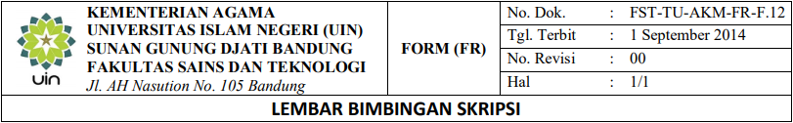

|  |  |  |  |  |
| --- | --- | --- | --- | --- |
| NIM | :……………………………… |  | Tanggal SK | :……………………….. |
| NAMA | :……………………………… |  | Pembimbing I | :……………………….. |
| Jurusan | : Teknik Informatika |  | Pembimbing II | :……………………….. |
| Judul | : |  |  |  |
| ………………………………………………………………………………………………………………..  ………………………………………………………………………………………………………………..  ………………………………………………………… | | | | |

|  |  |  |  |  |
| --- | --- | --- | --- | --- |
| Perte-  muan ke- | Tanggal Bimbingan | Materi Bimbingan | Saran/Perbaikan | Paraf Pembimbing |
| 1 |  |  |  |  |
| 2 |  |  |  |  |
| 3 |  |  |  |  |
| 4 |  |  |  |  |
| 5 |  |  |  |  |
| 6 |  |  |  |  |
| 7 |  |  |  |  |
| 8 |  |  |  |  |
| 9 |  |  |  |  |

|  |  |  |
| --- | --- | --- |
| Mengetahui:  Ketua Jurusan, |  | Bandung……………………………..  Mahasiswa, |
| Cepy Slamet, S.T.,M.Kom.  NIP.1928002252011011007 |  | ………………………………………  NIM. |